NOW HIRING!

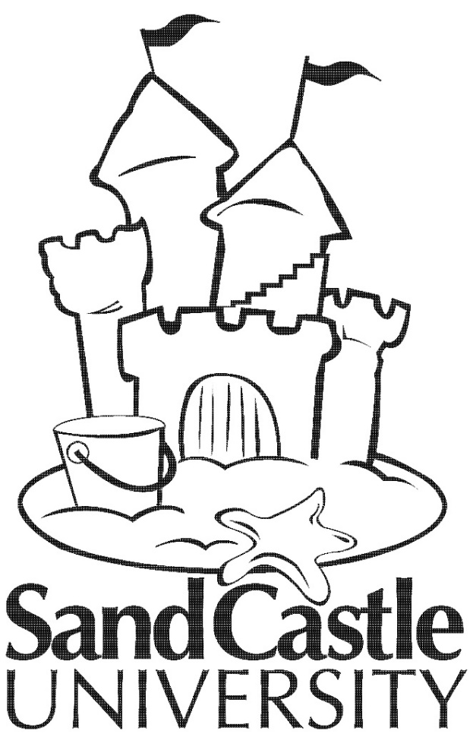

Is the beach your happy place? Have you ever wanted to build a proper sand castle?
We have the job for you! Sand Castle University will train you not only to build the perfect sand castle, but also how to teach others to do the same!
- No sculpting experience necessary.
- Big personality and lots of patience preferred.
- Seasonal position from March-August teaching private sand castle classes
- March Training at “Sand Castle Instructor Boot Camp” - $12/hr
- Pay after training starts at $15/hr
- Flexible schedule – YOU CHOOSE!
- 18 years old or over to apply

If interested; please contact Belinda Tucker or Britney Long at 251-943-8725 or email us at btucker@longshrs.com or blong@longshrs.com.

